

Lab Mid Term
  - OOP
Instructor: Mr. Mohsin Ahmed

Student Name: |  | Syeda Aima Abbas
Registration No: |  | FA24-BSE-010
Department: |  | Software Engineering
Submission Date: |  | 23rd October 2025

  - COMSATS University Islamabad

SOLUTION OF Q#1

CODE:

abstract class Vehicle {

private String vehicleNumber;
private String ownerName;

public Vehicle(String vehicleNumber, String ownerName) {
this.vehicleNumber = vehicleNumber;
this.ownerName = ownerName;
}

public String getVehicleNumber() { return vehicleNumber; }
public String getOwnerName() { return ownerName; }

public abstract double calculateParkingFee(int hours);
}

class Car extends Vehicle {
private final double firstHourFee = 50;
private final double perHourRate = 30;

public Car(String vehicleNumber, String ownerName) {
super(vehicleNumber, ownerName);
}

@Override
public double calculateParkingFee(int hours) {
if (hours <= 1) return firstHourFee;
return firstHourFee + (hours - 1) * perHourRate;
}
}

class Bike extends Vehicle {
private final double firstHourFee = 20;
private final double perHourRate = 10;

public Bike(String vehicleNumber, String ownerName) {
super(vehicleNumber, ownerName);
}

@Override
public double calculateParkingFee(int hours) {
if (hours <= 1) return firstHourFee;
return firstHourFee + (hours - 1) * perHourRate;
}
}

class Truck extends Vehicle {
private final double firstHourFee = 100;
private final double perHourRate = 60;

public Truck(String vehicleNumber, String ownerName) {
super(vehicleNumber, ownerName);
}

@Override
public double calculateParkingFee(int hours) {
if (hours <= 1) return firstHourFee;
return firstHourFee + (hours - 1) * perHourRate;
}
}

class ParkingSlot {

private Vehicle vehicle;

public ParkingSlot(Vehicle vehicle) {
this.vehicle = vehicle;
}

public void calculateAndDisplayFee(int hours) {
double fee = vehicle.calculateParkingFee(hours);

System.out.println("\nVehicle Number: " + vehicle.getVehicleNumber());
System.out.println("Owner Name: " + vehicle.getOwnerName());
System.out.println("Parked Hours: " + hours);
System.out.println("Total Parking Fee: Rs. " + fee);
}
}

public class SmartParkingSystem {
public static void main(String[] args) {

Vehicle car = new Car("CAR-123", "Ali");
Vehicle bike = new Bike("BIKE-456", "Sara");
Vehicle truck = new Truck("TRUCK-789", "Ahmed");

ParkingSlot slot1 = new ParkingSlot(car);
ParkingSlot slot2 = new ParkingSlot(bike);
ParkingSlot slot3 = new ParkingSlot(truck);

slot1.calculateAndDisplayFee(3);
slot2.calculateAndDisplayFee(2);
slot3.calculateAndDisplayFee(5);
}
}

OUTPUT:
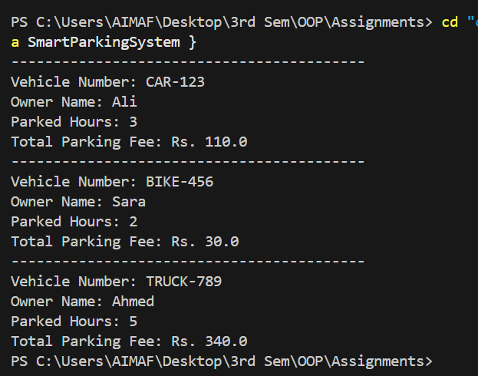

SOLUTION OF Q#2

CODE:
import java.util.*;

abstract class SmartDevice {
private String id;
private String name;
private boolean power;
private String network;

public SmartDevice(String id, String name) {
this.id = id;
this.name = name;
this.power = false;
this.network = "Not Connected";
}

public String getName() { return name; }

public void connect(String network) {
this.network = network;
System.out.println(name + " connected to " + network);
}

public void turnOff() {
power = false;
System.out.println(name + " turned OFF.");
}

public abstract void turnOn();
public abstract void showStatus();
}

class SmartLight extends SmartDevice {
private int brightness = 0;

public SmartLight(String id, String name) {
super(id, name);
}

@Override
public void turnOn() {
brightness = 80;
System.out.println(getName() + " turned ON with brightness " + brightness + "%");
}

@Override
public void showStatus() {
System.out.println("Light: " + getName() + " | Brightness: " + brightness + "%");
}
}

class SmartFan extends SmartDevice {
private int speed = 0;

public SmartFan(String id, String name) {
super(id, name);
}

@Override
public void turnOn() {
speed = 3;
System.out.println(getName() + " turned ON at speed " + speed);
}

@Override
public void showStatus() {
System.out.println("Fan: " + getName() + " | Speed: " + speed);
}
}

class SmartThermostat extends SmartDevice {
private double temperature;
private TemperatureSensor sensor;

public SmartThermostat(String id, String name, double temp) {
super(id, name);
this.temperature = temp;
this.sensor = new TemperatureSensor();
}

public void changeTemperature(double temp) {
temperature = temp;
}

public void changeTemperature(double value, String unit) {
if (unit.equalsIgnoreCase("F"))
temperature = (value - 32) * 5 / 9;
else
temperature = value;
}

@Override
public void turnOn() {
System.out.println(getName() + " turned ON at " + temperature + "°C");
}

@Override
public void showStatus() {
System.out.println("Thermostat: " + getName() +
" | Set Temp: " + temperature + "°C" +
" | Sensor: " + sensor.readTemperature() + "°C");
}

private class TemperatureSensor {
public double readTemperature() {
return temperature + 0.5;
}
}
}

class CentralController {
private List<SmartDevice> devices = new ArrayList<>();

public void addDevice(SmartDevice d) {
devices.add(d);
}

public void connectAll(String network) {
for (SmartDevice d : devices) d.connect(network);
}

public void turnOnAll() {
for (SmartDevice d : devices) d.turnOn();
}

public void showAllStatus() {
for (SmartDevice d : devices) d.showStatus();
}

public void turnOffAll() {
for (SmartDevice d : devices) d.turnOff();
}
}

public class SmartHomeSystem {
public static void main(String[] args) {
CentralController controller = new CentralController();

SmartLight light = new SmartLight("L1", "Living Room Light");
SmartFan fan = new SmartFan("F1", "Bedroom Fan");
SmartThermostat thermostat = new SmartThermostat("T1", "Main Thermostat", 22.0);

controller.addDevice(light);
controller.addDevice(fan);
controller.addDevice(thermostat);

controller.connectAll("Home_WiFi");
controller.turnOnAll();

thermostat.changeTemperature(77, "F");

controller.showAllStatus();
controller.turnOffAll();
}
}

OUTPUT:
